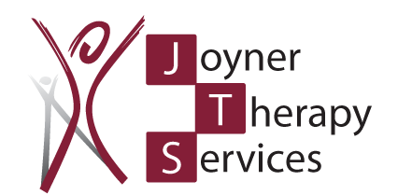 WE ARE HIRING IN CARMI!

- Licensed Massage Therapist
- PRN Physical Therapy Assistant

We will be happy to provide more details for each position. Just call Jaymie at 618-998-9894 x 308 or email your resume to jobs@joynertherapyservices.com

