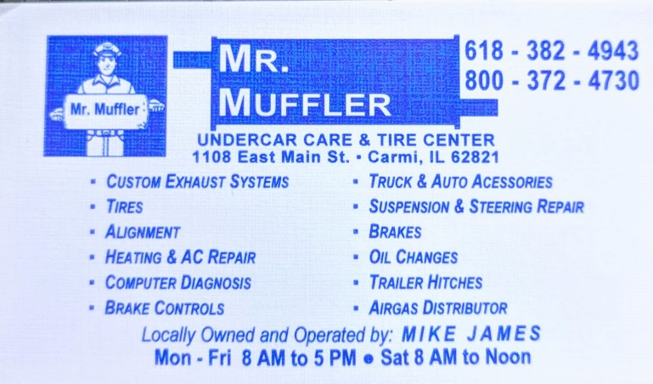 HIRING FULL-TIME MECHANIC
Mr. Muffler in Carmi is looking to hire a full-time mechanic.

Hours are Monday-Friday 8am-5pm.

Must be 18 or over and have a valid driver’s license. Previous mechanical experience preferred.

Must be familiar with general vehicle repairs and services etc. Willingness to learn is a plus.

Please apply in person only. Applications are available to fill out on site.

Any questions? Call us at 618-382-4943.

