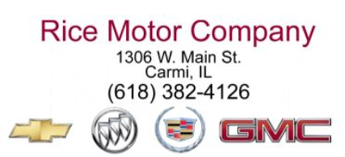
Rice Motor Company, a leader in the local automotive industry for more than 90 years has an opening for an ASE Certified Mechanic.
We’re looking for a dedicated service professional to help accelerate our growing service department and provide customers with exceptional experiences.
The ideal candidate will flourish in a fast – paced and professional workplace and must take direction from supervisors well.
Responsibilities:
• Perform work specified on the repair order with efficiency and in accordance with dealership standards
• Test components and systems using diagnostic tools and special service equipment
• Diagnose, maintain, and repair vehicle automotive systems including engine, transmission, electrical steering, suspension, brakes, air conditioning, etc.
• Communicate directly with the Service Manager so that customers can be informed if any additional service is needed. Provide an estimate of time needed for additional repairs
• Execute repairs under warranty to manufacturer specifications
Job Type:
Full-Time
We offer:
Extensive training program
Modern and Professional work environment
Paid Vacation
Employee Discounts
Schedule:
Monday – Friday
Experience:
Automotive Repair (2 year preferred)
License/Certification:
Driver’s License
ASE Certification (preferred, will consider minimum of 3 years’ experience and intent to become certified)
How to apply:
Stop by the dealership on Main Street to pick up and fill out an application or to drop off your resume. Call 382 – 4126.

